

**CSM3103 FRONT-END PROGRAMMING(K1)**

**BACHELOR OF COMPUTER SCIENCE (MOBILE COMPUTING) WITH HONORS**

**SEMESTER 2 2023/2024**

**LAB 3 – Cordova Plugins**

**Prepared for:**

DR. RABIEI MAMAT

**Prepared by:**

MUHAMMAD HAZIQ AIMAN BIN MUSTAFA (S67978)

Task1

Output:

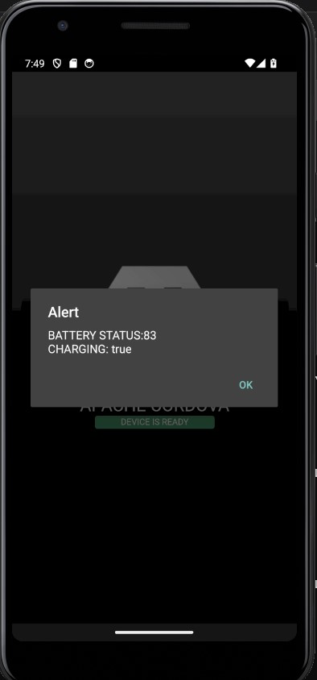

Task 2:

Output:

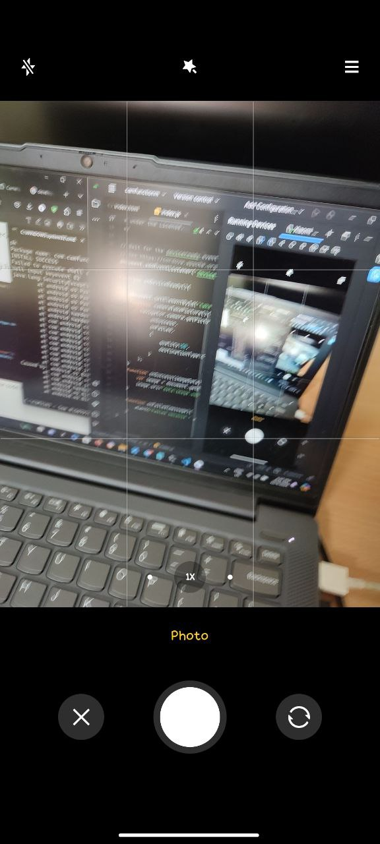 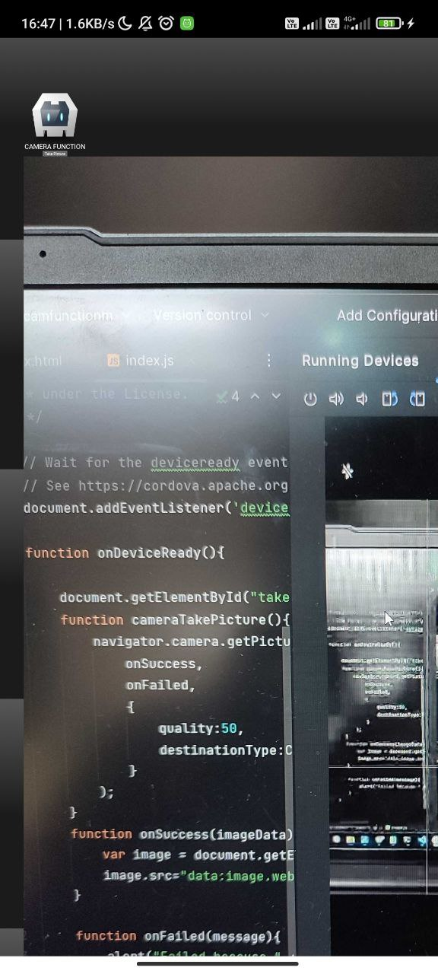

Task 3:

Output:

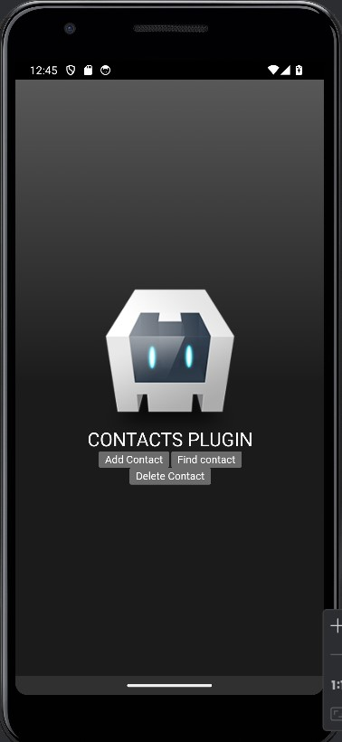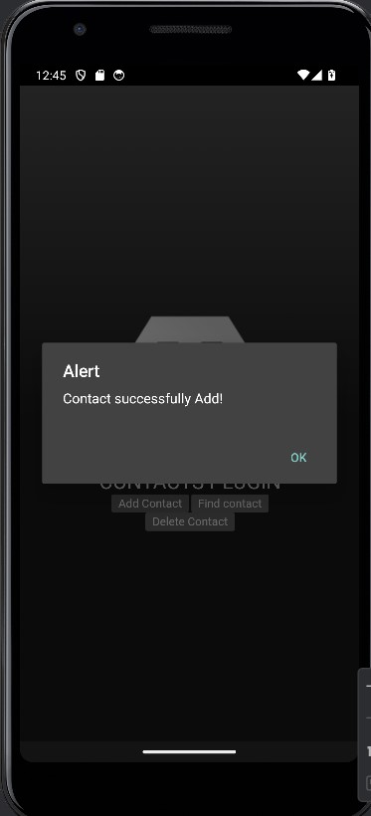

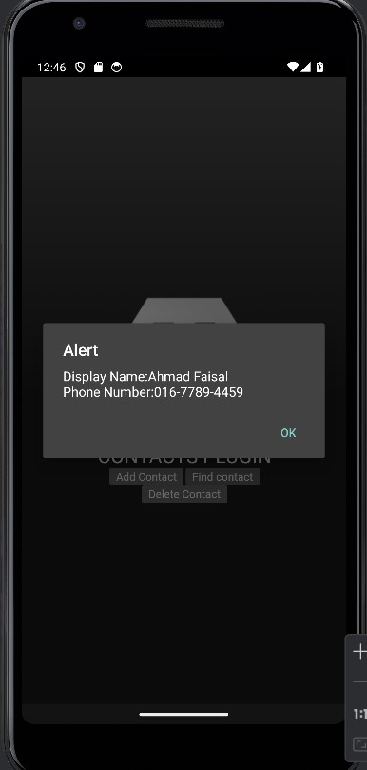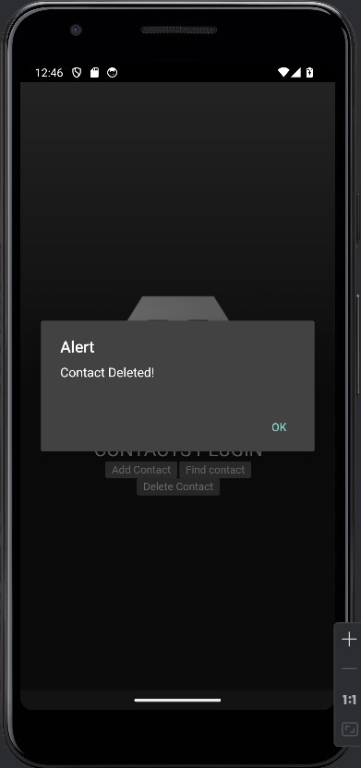

Task 4:

Output:

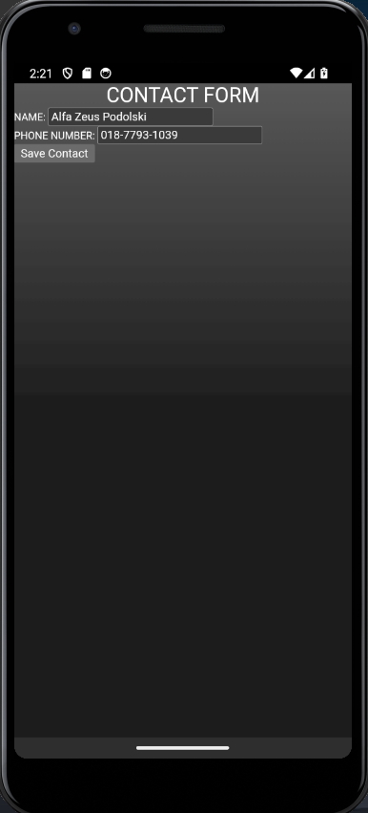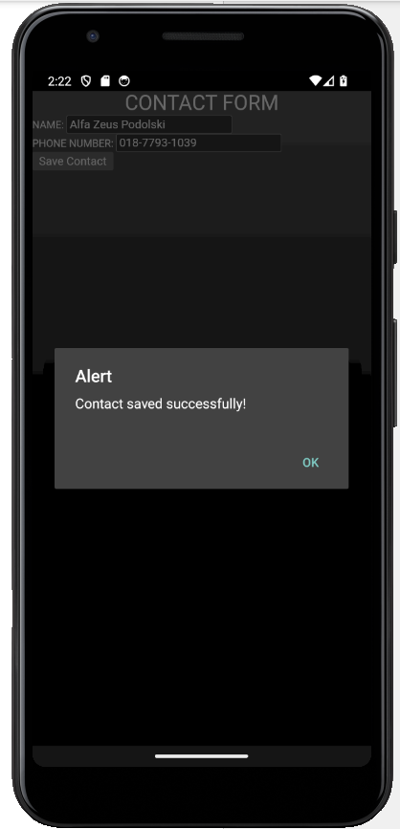 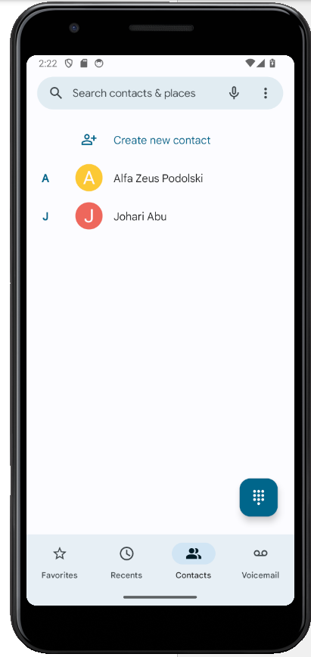

Task 5:

Output:

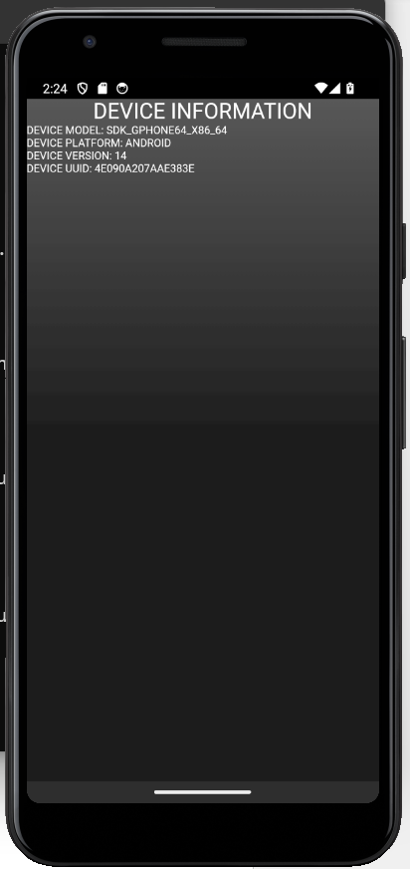

Github link:

<https://github.com/ziqmunk/CSM3103/tree/08e0b3e89768050d9925b13065b87eec55f32005/S67978%20-%20Lab3>